# Project Type: Data Analysis & Visualization Project

# Project Name: Electronic Products Catalog

# Document Type: MongoDB Installation

# Group 7

Astha Rastogi

Ankita Roy

Eric Pozholiparambil

Shweta Pathak

# Project Information:

Our Project deals with about 15000 electronic products with their respective brands, availability, sales and other characteristics such as whether the product is on sale and involves shipping cost or not.

We encountered certain issues while we were executing the project. They are all mentioned below along with the measures that we took to handle them and successfully execute the project.

# MongoDB Installation:

## Installation of Mongo DB Community Edition:

1. Go to: <https://docs.mongodb.com/manual/administration/install-community/>

And choose the type of your computer and then download the file.

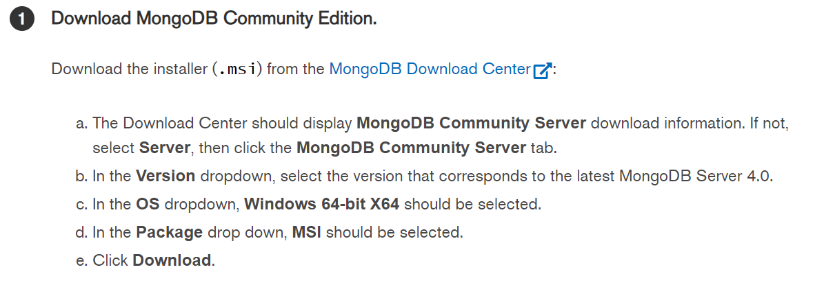

1. Once downloaded, run the installer which is the .msi and then run the default instructions on the install wizard.

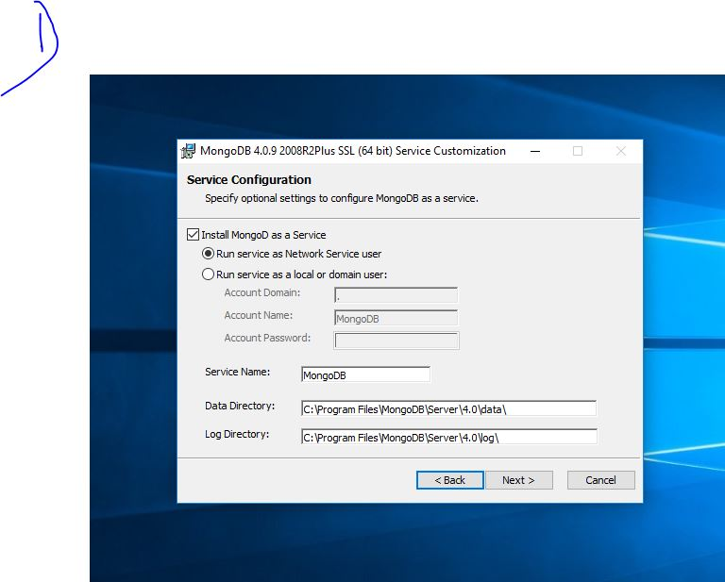

Installation of BI Connector for Mongo DB:

In order to connect Mongo DB with any BI tool for visualization purpose, we need to use the BI connector which is provided by Mongo DB community.

1. Go to <https://docs.mongodb.com/bi-connector/master/installation/> and choose your respective OS and click on download.

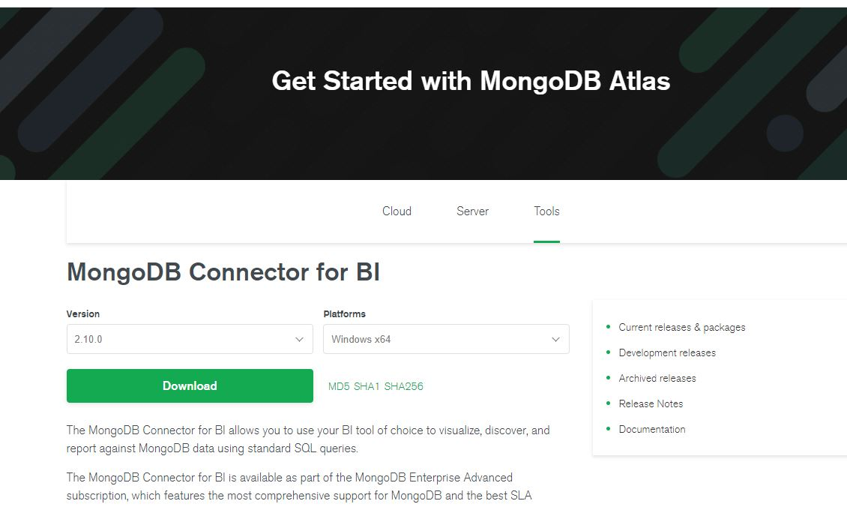

1. It will prompt you for your details which you can fill in and the download starts.

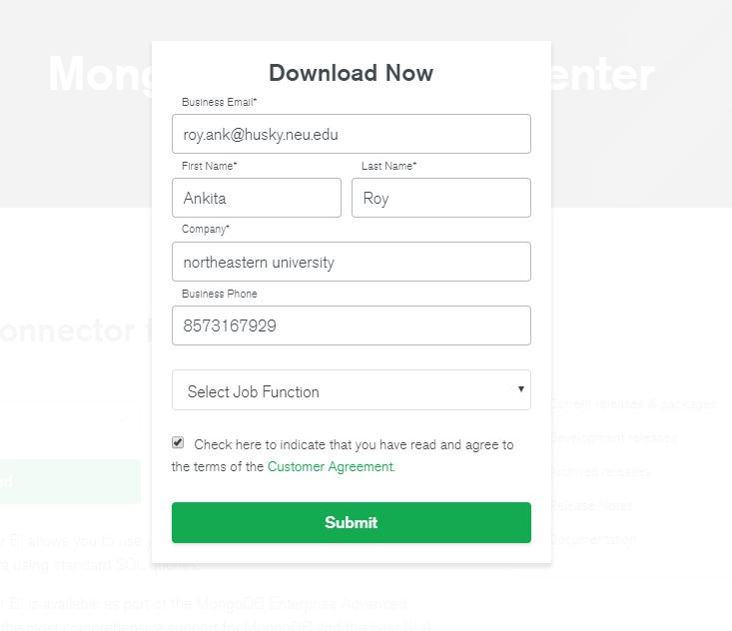

1. After the download, just follow the instructions mentioned on the installer and the connector will be downloaded.

## Installation of ODBC Driver for Mongo DB:

1. Go to <https://github.com/mongodb/mongo-odbc-driver/releases/> and download the version which corresponds to your operating system configuration. Documentation is available at: <https://docs.mongodb.com/biconnector/master/reference/odbc-driver/>

Configuring the ODBC Driver:

1. After downloading the 3 components, start the Mongo DB BI connector on the command prompt. This will help us identify the port number on which it works to connect BI tool and Mongo DB.

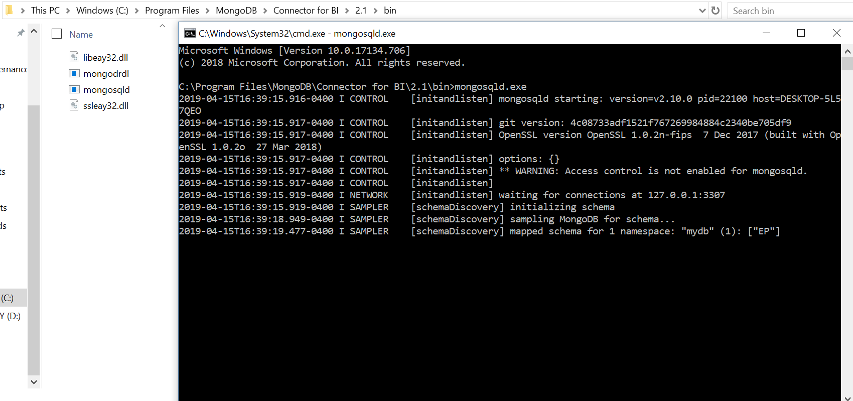

1. Once the connector is running on port 3307, we start the ODBC Connector by typing it on the ‘Start’ tab of the computer.
2. Once you open the ODBC connector, connect it by filling the respective information as shown below. (Notice, to test the connection, you need some data in your MongoDB. For this we have already built the database ‘mydb’)

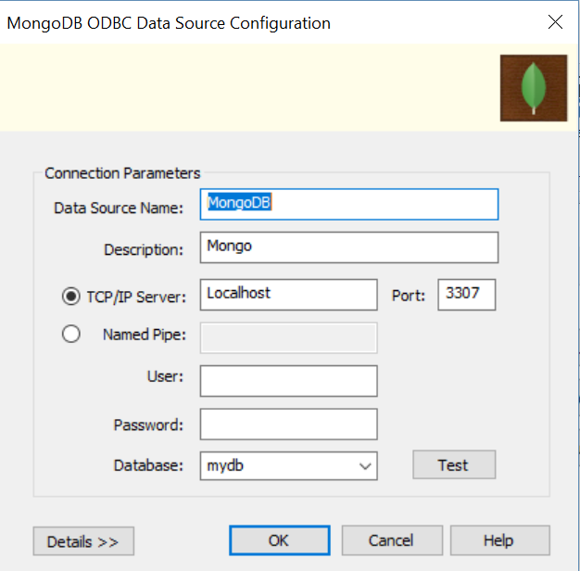

1. After filling in the details correctly, you can test the connection and it will let the user know if the connection is successful or fails.

## In all for the proper connectivity of Mongo DB with Microsoft Power BI using ODBC Driver, we need the following 3 installations:



